Kibana and Elastic Search

VETS system state and test result information has been pushed to the Elastic Search server. We can display this information on the Kibana dashboard in various ways using a combination of visualization techniques.
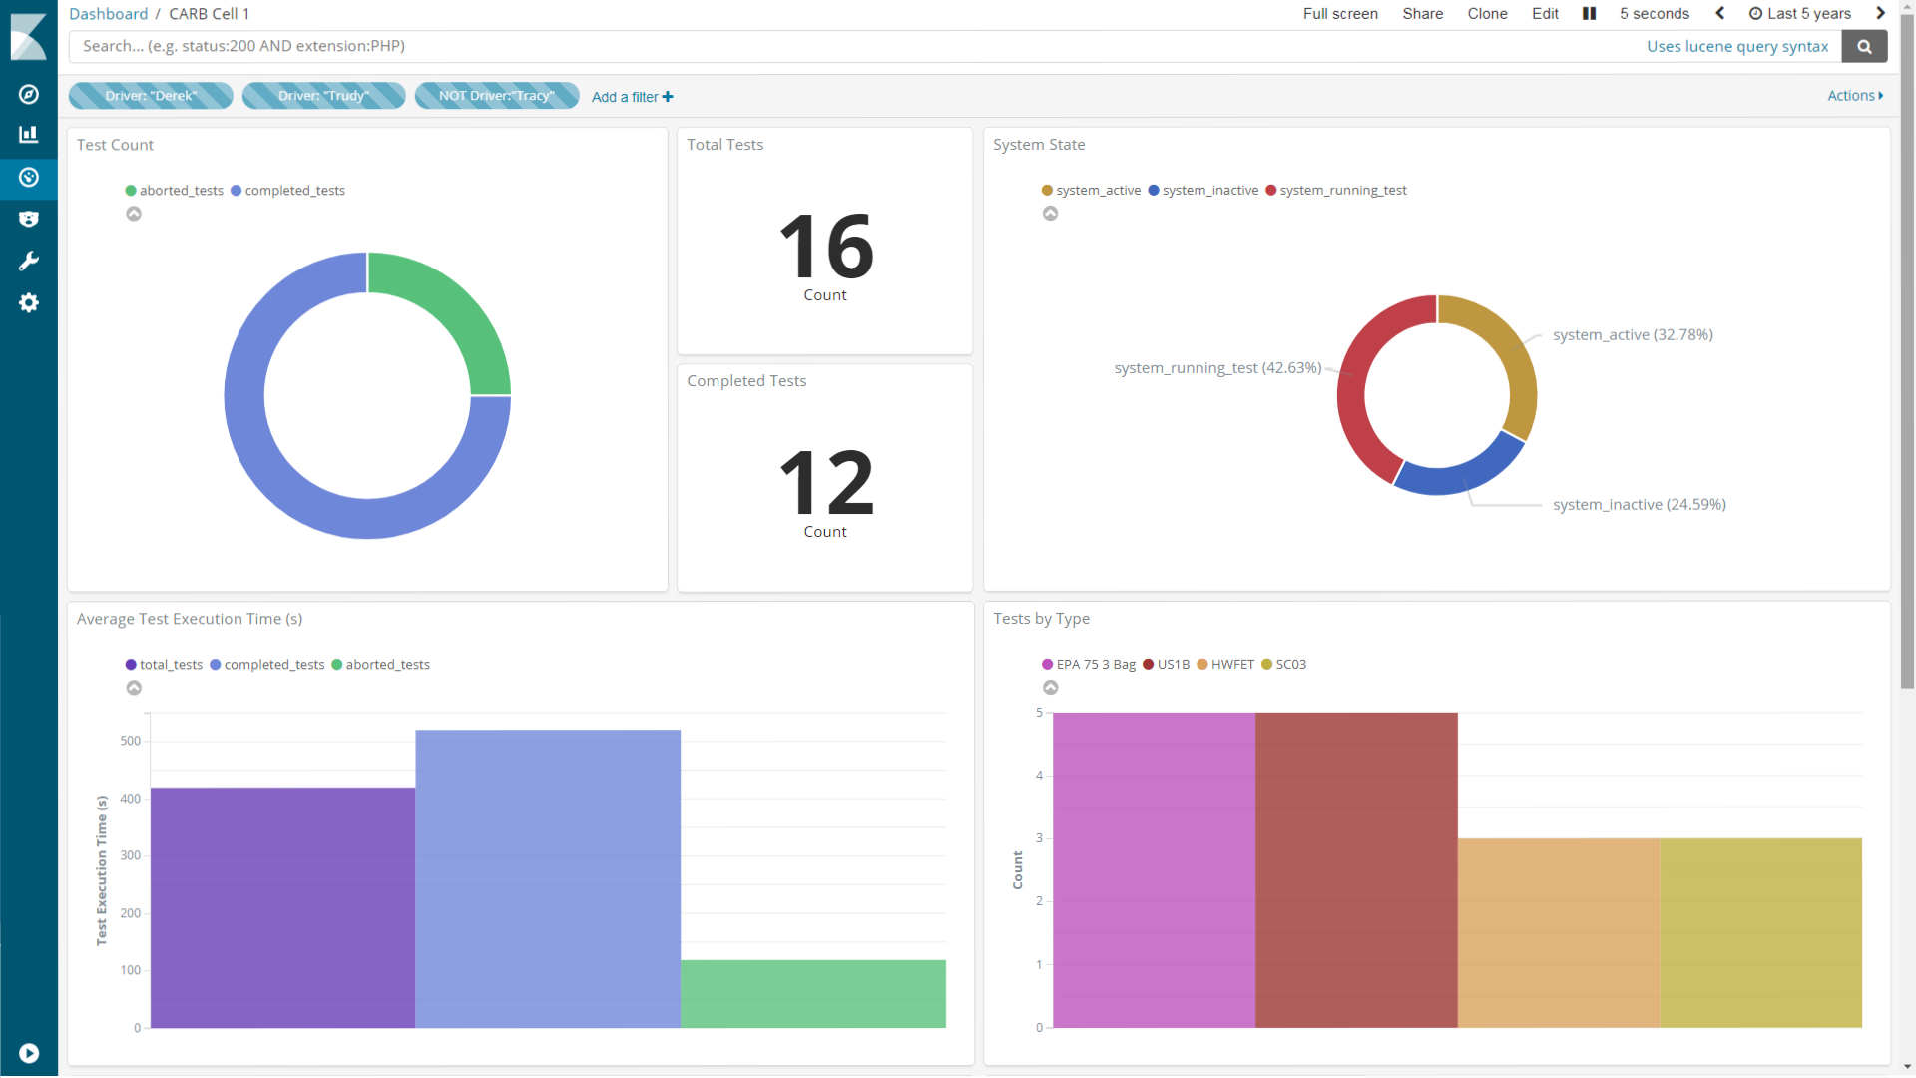

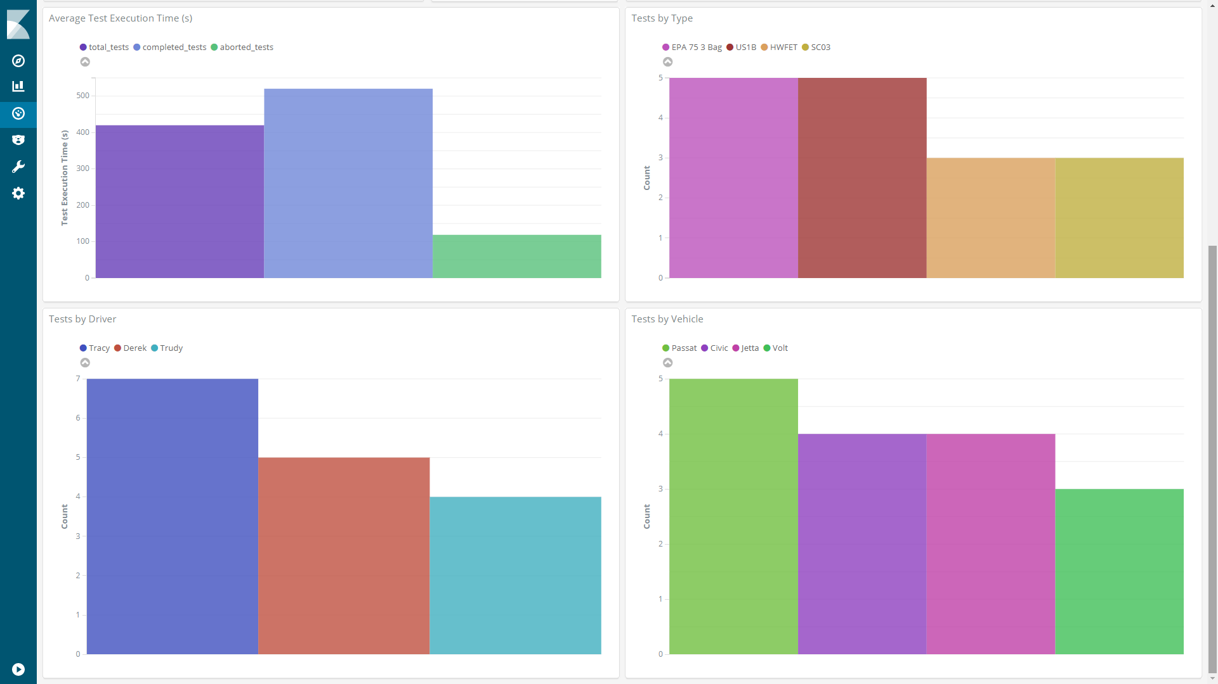

We can apply filters to the data, here we apply the Driver: “Derek” filter. Test result data will be filtered so that displayed information is constrained to instances of tests where the driver is “Derek”.
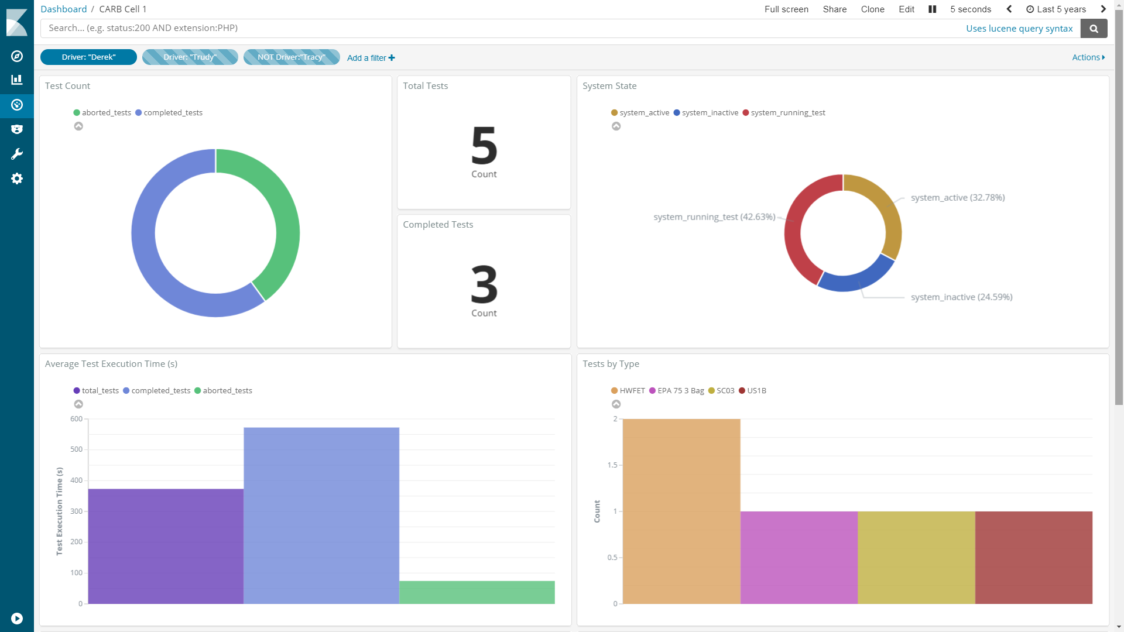

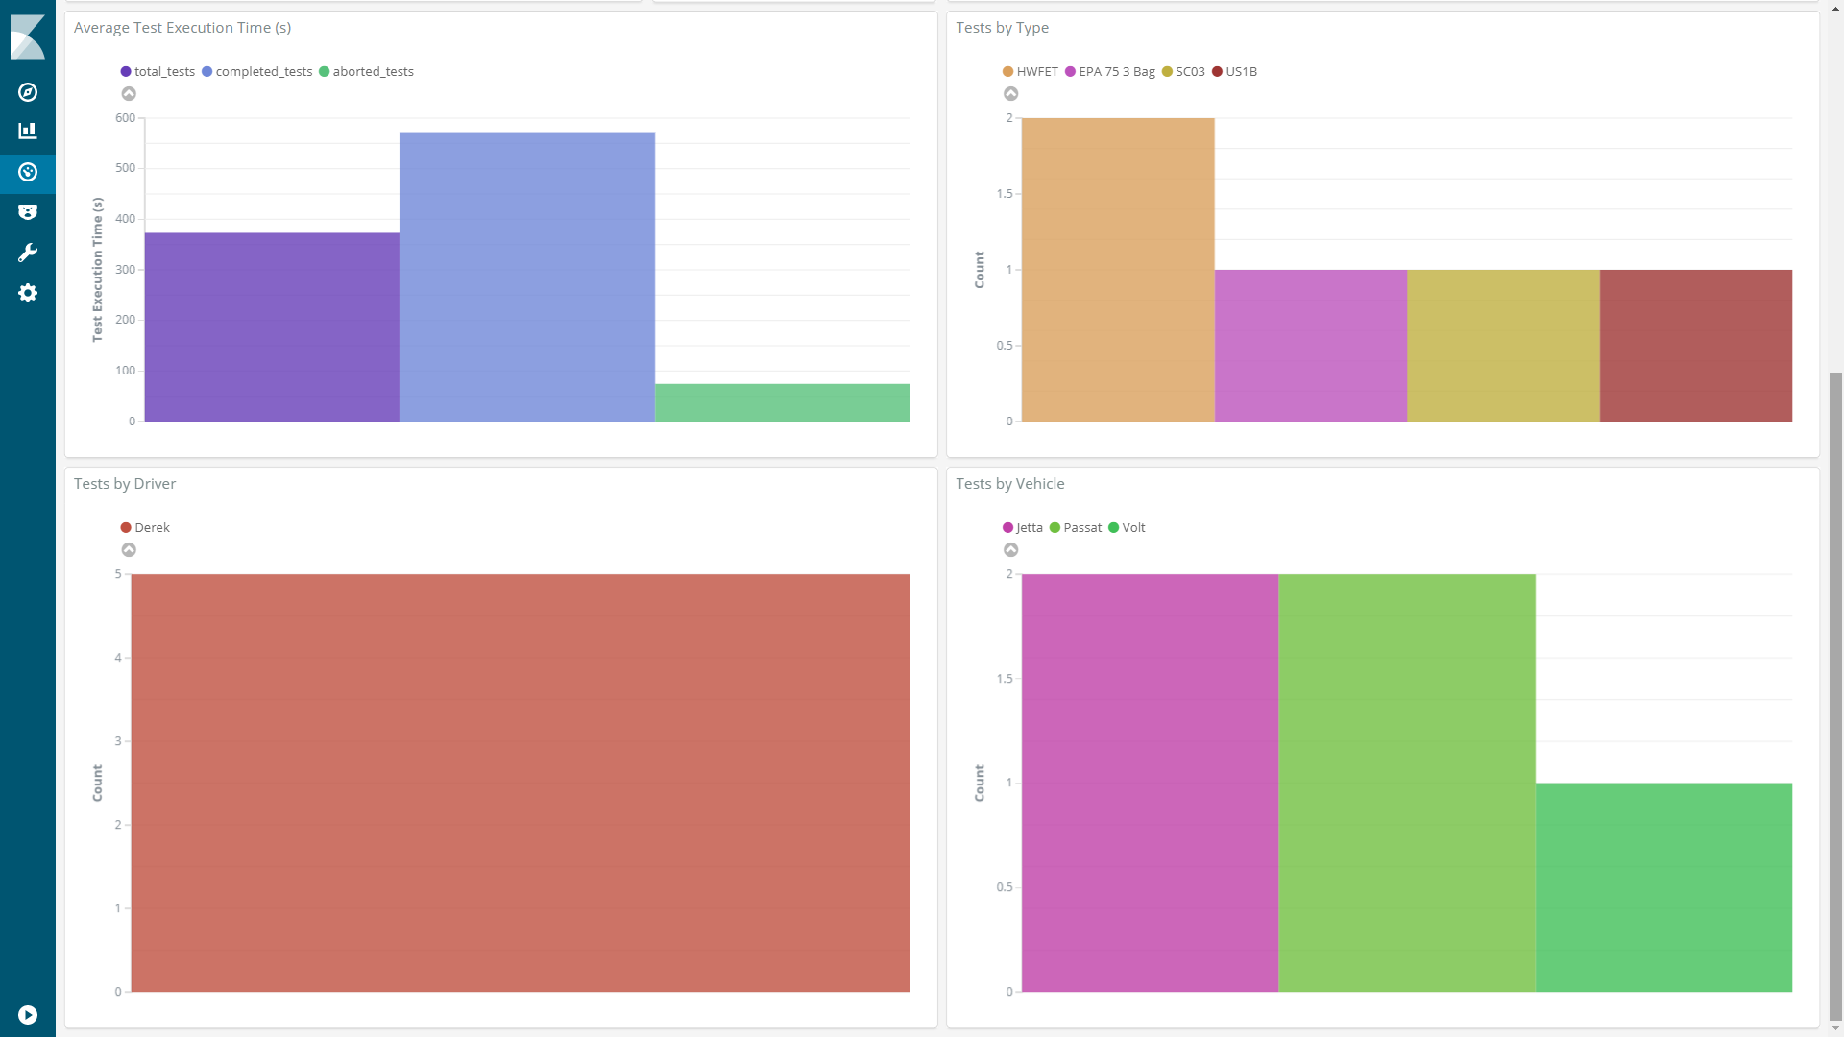

We can also apply time constraints to the data. Here we choose to only show data which was logged between April 5th 2018 3:40:46 AM and April 20th 2018 7:34:59 AM.
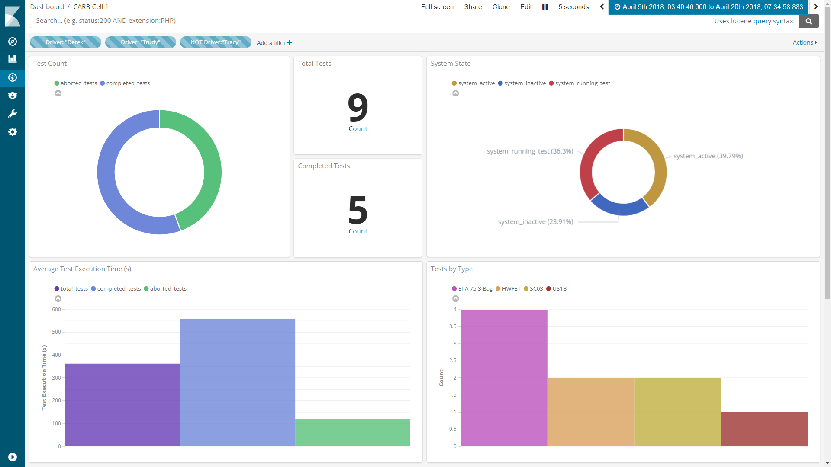

We can apply filters on top of time constraints.
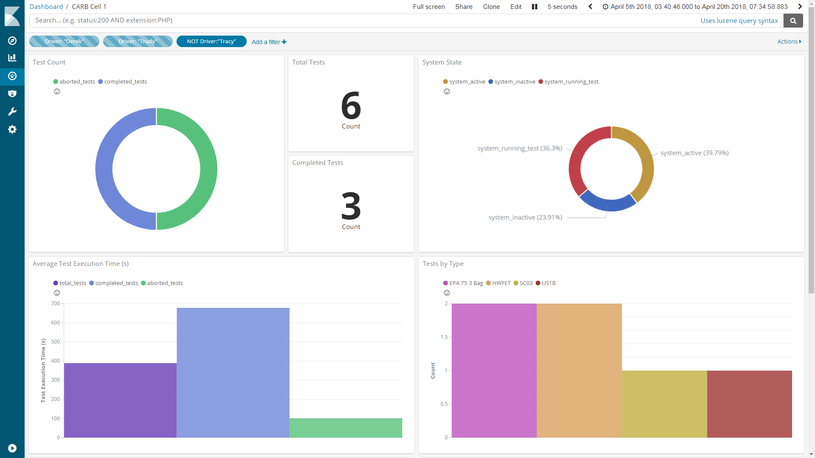

Hovering over a graph will provide further information.
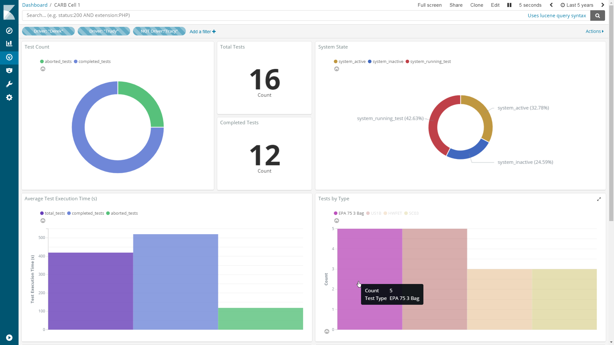

We can click on the graph to automatically create and apply a filter for that piece of data.
